

**Visual structure – how can it help?**

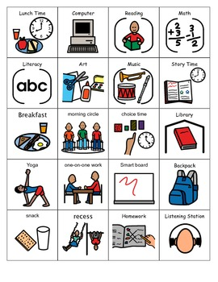

Understanding what is happening and when can reduce anxiety and challenging behaviour. Children with autism typically respond well to routine and predictability and it helps them to make sense of everyday life. Visual structure is just as important for the holidays as well as during term time. There are many ways to develop visual structure in the home or when out and about. What is used will depend on what suits your child.

You don’t have to have autism to benefit from having visual structure; most children are accustomed to using timetables, calendars and of course mobile phones – these can also be used as timers.

* 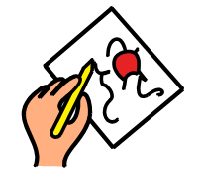Visuals remove the need for the child to keep checking what’s happening
* Getting annoyed at being reminded what to do.
* Can help with transitions/change
* Provide a consistent format for supporting the spoken word and are permanent.

Visuals can consist of: - White boards; post its; written lists; texts sent to the phone; single words, drawings, PowerPoints to name a few.

There are set events during a day that always happen, and we can build the days structure around these events. The set events are of course snack/meal times and bedtime. For some children it may be that at the beginning of the day you sit down together and set out what will be happening and in what order for the whole day **OR** you may choose to plan out the time after breakfast and before lunch then after lunch plan out the time to tea time and finally tea time to bedtime **OR** you may use the “Now and Next” approach. It is important to use the system that suits your child and your family. For some children they may need to cross out what has happened so they can see what will be happening next.

You do not need to fill each hour with a planned activity – it is just as important to build in play time/computer game time/exercise/ TV / down time/ and an oops card – which means something different will be happening.

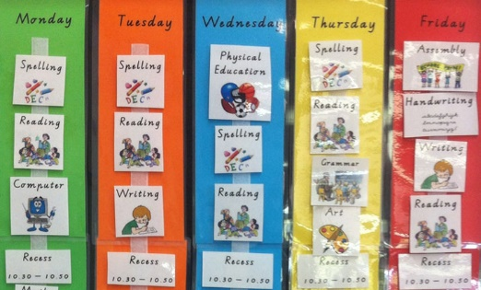The visual support systems can be kept on, doors, tables, walls - In fact anywhere in the close vicinity of the child, where they know they are and are at their level, with minimal background distraction. Be imaginative and use visuals in as many way as possible to enhance a child’s understanding and independence.

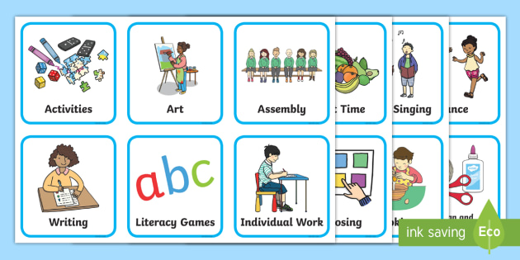





**Using Visual Structure to break up an activity or task**

With the challenge of providing education at home you may also need to help your child know how to break up a task/activity. Most children are not accustomed to learning at home and it is important that they can complete their work independently. This way of providing visual structure to break down a task can be adapted to meet your child’s needs.

Just think of a cooking recipe – it tells you what you need (Resources) and what you need to do to complete it (Method). Think of any task you expect your child to achieve independently - what would the recipe need to consist of.

**Example. 1 Task** – to find a picture of your favourite dinosaur, draw it and provide 3 facts about it.

**First** - Make a list of what is needed to complete the task.

Paper; coloured pens, dinosaur book or computer to research dinosaurs.

**Next** - Break down what they need to do

**Start** - Look at the dinosaur book and choose which is your favourite dinosaur. (or the computer)

Draw your favourite dinosaur, colour it in.

Label the dinosaur with its name.

Write down 3 facts you have learnt about this dinosaur.

**Finished task**

**Example. 2**

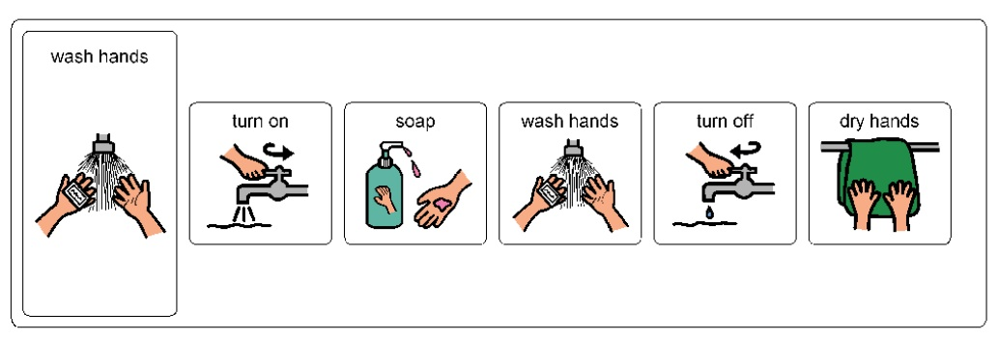Visual to break down how to wash your hands.

See examples/resources in the Autism Spectrum Team pack 2020.

****Check out our website for more information – Cornwall Autism Spectrum Team

There are currently lots of free resources on National Autistic Society web pages that can inspire you to make your own or you can download and print them out.