FRA Firefly – Parent Forgotten Password Help Sheet

Resetting your password

- Open up a web browser (Google Chrome, Firefox, Internet Explorer, Safari) and go to https://foweyriver.fireflycloud.net - the preferred browser for Firefly is Chrome.
- Click on Forgotten your password? as highlighted below

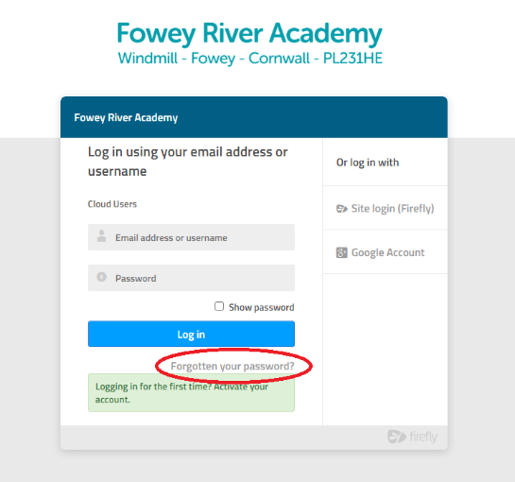
- Enter the email address that you provided to Fowey River Academy and then click Reset password. An email is then sent to you.
- Open the email and select click the link to reset your password.
- If you cannot find the email, please check your Junk and spam filters.
- Enter a password of your choice and then confirm it.
- You should now be logged into Fowey River Academy’s Firefly website.

Logging In

- Open up a web browser (Google Chrome, Firefox, Internet Explorer, Safari) and go to https://foweyriver.fireflycloud.net
- Enter your login credentials & password and select Log In.
- You should now be logged into Fowey River Academy’s firefly where you will see the Parents dashboard with links to parent resources.

Firefly have provided a number of in depth-guides on their website which you can view at http://help.fireflylearning.com/parents

