POWER
A bespoke curriculum co-created with young people for young people.

A strength-based collaborative and coordinated programme that aims to build student, parent and teacher knowledge in a progressive and developmental way.

The programme will have a systems approach to allow us to increase the protective factors and decrease the risk factors for all of our students ensuring they feel safe and loved. Therefore allowing them to be the best versions of themselves and to thrive now and in their futures.

How POWER is delivered
In Key Stage 3 all students will have one 75-minute lesson per week with additional project week workshops

In Key Stage 4 all students will receive 30-minute snapshots of POWER during their tutor time delivered by a trained specialist. They will also take part in a range of workshops delivered during project weeks.

Students will be given the opportunity to take part in peer mentoring, student voice and enrichment workshops throughout the year.

Staff training will take place during Friday TeachMeet at the start of each new topic
Parent workshops will take place via video workshops in each semester along with recommended reading, activities to complete at home and the offer of school contact. There will also be two parent workshops and “Tea and Talk” sessions per year.

There will be a dedicated page on the school website which will be updated to match the current teaching within the curriculum and provide support for students and parents beyond the school gates.

External agencies and organisations will be used to provide additional and expert support to our students, staff and parents.

The
Samantha Smith

FRA

P
O
W
E
R

P
R
O
G
R
A
M
M
E
As you continue on your journey into the world, you should know you are all kind, honest, global citizens who have the ability to accept responsibility for their own action, the curiosity and adaptability to be ambitious, courageous and open-minded enough to seek support to help you continue to grow and thrive in all areas of your life.
11
11
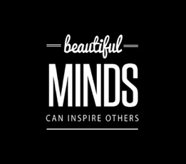  I will have developed: self-efficacy, self-concept, self-management and judgment.  Developed a range of stress management strategies and ways to stay safe.  Explored core concepts, values and emotions linked to relationships, stereotypes, gender identity, social issues and sexual orientation.  Be able to communicate assertively, understand signs of abuse and exploitation and access support.  Understand the role of drugs and alcohol and manage influence of peers and groups, including exit strategies. | Readiness for and communication in relationships  Exploring boundaries, harrassment and relationship abuse | Developing an appreciation of a range of cultures – Exploring moral and ethical viewpoints around animal rights, crime, conflict and the media. | Making healthy choices  Social, emotional and mental wellbeing. Stigma, risk and promoting the positive
Responsible citizens and confident individuals
Future proofing - Responsible health choices, and safety in independent contexts
Pregnancy choices, abortion and menopause.

I will: Have the independence and ability to set goals and have a range of effective revision strategies.
Explored issues, values, ethics and misconceptions around relationships to be able to make informed choices in my own life.
Be able to manage and resolve conflicts, explore the influence of peers, role models and substances on effective decision making. Establish effective exit strategies.
Be able to manage life online and challenge discrimination and have a deeper understanding of a range of cultural viewpoints on key issues.
Recognise the signs of mental ill health, challenge stigma, be able to apply strategies and seek support.

Empowering young people to see the possibility and the power of positive directions and choices

Building for the future, and new challenges. Independence and autonomy.  Explore, critically evaluate and manage influences on health | Developing an appreciation of a range of cultures- A deep dive into Christianity and a study into religion, peace and conflict. | Relationship values and equality  Social issues, the media and intersectionality. | Exploring different faiths, moral and ethical viewpoints. A deep dive into Buddhism or Islam. A study of relationships and families across different cultures.
Project week – Confident individuals and responsible citizens
Influences on health – protective and risk factors.
Marriage, civil partnerships and cohabiting. Reason for and against marriage, arranged and forced marriages
10

I will know: The risks and strategies to manage conflict in different contexts. Be able to manage the influence of peers, ‘distinguish between assertive and aggressive communication.
Have an understanding of morality and how to reduce racism.
The facts on safe sex, readiness for intimacy and the impacts of relationships on health.
The influence of media on expectations, manage risks of online material and know the difference between life on/off line.
The characteristics and legal status of relationships, how to manage breakdown and changes.
The relationship between physical and mental health, the importance of balance.
Including: social norms the legal and health risks of drugs, alcohol and the
influence of diet and body image.

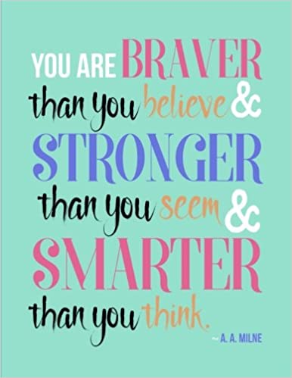
Allowing you to make the most out of this time of huge growth and opportunity to thrive now and in your future.

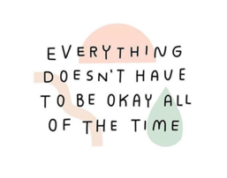  Exploring different faiths, moral and ethical viewpoints. Focus on morality and reducing racism. | Characteristics of Respectful relationships.  Intimate relationships and consent. | Focus on happiness, suffering and life after death. | Developing an understanding of happiness and success. Exploring influences on health and how to seek support.
Project week - Responsible citizens and effective contributors.
Health lifestyle and balance – time outdoors, volunteering and community participation.
Understand impact on others exploring equality, stereotypes and respect in the school and wider community. Become a leader, develop self-confidence through Innovation Labs

I will: know how to be emotionally safe and able to bounce back after setbacks.
Have a range of strategies to cope with and help others cope with mental ill health
Understand the importance of tolerance and respect in relation to protected characteristics
gender identity and different faiths
Have interpersonal effectiveness and be able to make safe, healthy choices in a range of relationships.
Have awareness of positive social norms and an awareness of habit and dependence around drugs/alcohol/tobacco and energy drinks

9

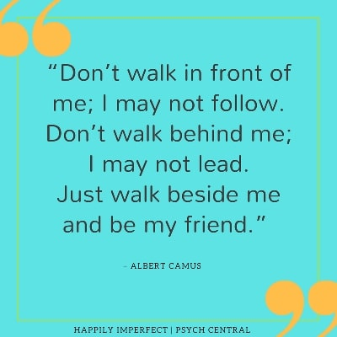
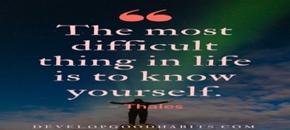
Exploring different faiths, moral and ethical viewpoints. Focus on Christianity | Diversity, identity and my place in the world  Self-worth and building relationships | Developing an appreciation of a range of cultures. Focus on Christianity. | Managing change, challenge and transitions. Self and social awareness. Health, wellbeing, safety and risk
Project week – Responsible citizens and confident individuals
What does it mean to be safe and well?
Overall wellbeing, importance of healthy lifestyle and first aid

Building gratitude into your daily lives. Enabling you to feel more positive emotions, relish good experiences, improve health, deal with adversity and build strong relationships

I will: be aware of my own identity, purpose, strengths, role and responsibilities in an ever-changing world.
Be aware of different religions and cultural beliefs.
Have developed strategies to help deal with risk, change and keep myself safe and healthy.
Feel comfortable and confident in how I develop and maintain positive, safe and effective relationships.
Developing an understanding of and exploring the influences in health, attitudes to mental health, online resilience and substances. | Appreciation of a range of cultures. Focus on Buddhism and Islam. | Diversity and purpose.  Relationships and communication. | Exploring different faiths, moral and ethical viewpoints. Focus on Sikhism and reducing racism.
Project week - Responsible citizens and confident individuals
Healthy lifestyle choices, emotional wellbeing and online safety

8

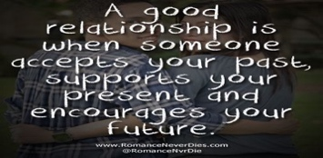
The aim is to keep moving forward in this amazing time of growth and opportunity.

Finding your purpose is a lifelong adventure. Enjoy the journey

Gratitude journaling
Target setting
Transition celebration
7
Experiences
Transition celebration

