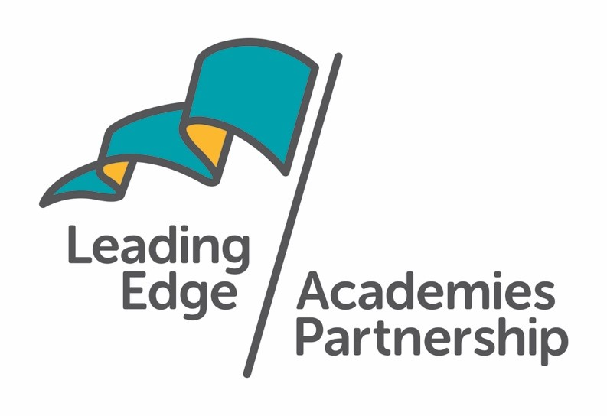

CAREERS EDUCATION,
INFORMATION, ADVICE
AND GUIDANCE (CEIAG) POLICY

FOWEY RIVER ACADEMY

Last review date | January 2023
Date for next review | January 2024

Vison
Our vision has FRA students at the heart if a connected community where they thrive and make a difference locally and globally, where they are proud to say, “I went to Fowey” and where the community is proud of them and us.

Rationale
The aim of the Careers Programme at Fowey River Academy is to provide students with the information and opportunities they require to enable them to make informed decisions about their future learning or career. The importance of careers education and guidance has never been greater due to significant and ongoing changes in education, training and employment. Young people face an increasingly complex and challenging employment landscape with youth unemployment and underemployment at high levels. High quality careers provision can help increase social mobility.
In the foreword of the 2017 DFE document “Careers strategy: making the most of everyone’s skills and talents,” the Rt Hon Anne Milton, the Minister of State for Apprenticeships and Skills and Minister for Women states “Our careers provision must be world class to help people understand the range of opportunities available to them in today’s economy and acquire the skills and qualifications they need to succeed in the workplaces of the future.”
Qualifications such as GCSE, A-level and BTEC have undergone significant changes in recent years and students need help to make choices and manage transitions. T-levels are a new qualification being introduced in 2020. Apprenticeships are now being linked to a much wider range of jobs and professions and are increasingly available at Advanced and Higher as well as Intermediate level. Level 6 apprenticeships, which are equivalent to undergraduate level are now available. Higher education opportunities increasingly extend beyond the UK. Students need help to make choices and manage transitions in a rapidly changing world.

Aims of the CEIAG programme at Fowey River Academy:

- To focus students on their future aspirations
- To contribute to strategies for raising achievement, especially by increasing motivation
- To support inclusion, challenge stereotyping and promote equality of opportunity
- To encourage participation in continued learning including further and higher education
- To develop employability and enterprise skills
- To reduce drop out and course switching in education and training
- To meet the needs of all our students through appropriate differentiation
- To enable parents and carers to support their children make informed career decisions

Commitment
Governors and staff are committed to providing a planned Careers programme for all students throughout their five years at Fowey River Academy. The programme promotes equality of opportunity and all students are supported to gain access to education, training or employment.
A key element of the programme is to provide students with the opportunity to meet and communicate with employers, employees, further education, higher education and training providers. The school has well developed links with a range of local businesses and organisations.

Fowey river Academy’s Careers Programme consists of a range of activities that help students make choices that are right for them and will help them manage their future careers. Starting in Year 7, students are encouraged to use self-assessment to identify their strengths and areas of interest. They will be helped to review their achievements, plan their future actions, make decisions, present themselves and cope with change and transition. All students will be encouraged to make good use of the information and impartial guidance available in the school. They will learn about the changing nature of work, career choices and other relevant information which will affect their decisions.

Fowey aims to achieve all eight Gatsby Benchmarks:

- A stable careers plan
- Learning from careers and labour market information
- Addressing the needs of each pupil
- Linking curriculum learning to careers
- Encounters with employers and employees
- Experiences of workplaces
- Encounters with further and higher education
- Personal guidance

The school evaluates its careers provision using the Gatsby Benchmarks and draws up a development plan to address the identified areas for development.

Since the introduction of the new CDI Career Development Framework in 2022, we also have a commitment to evaluate our provision against the six career development skills that people need to have positive careers,

These six learning areas are:

- Grow throughout life
- Explore possibilities
- Manage Career
- Create opportunities
- Balance life and work
- Seeing the big picture

The 2017 Careers Strategy has set schools a target of seven encounters with employers or employees for all students, by the end of March 2020. Fowey River Academy is committed to providing students with high quality encounters through a range of activities, including; a careers fair during each academic year; business volunteers taking assemblies and being involved in lessons; speed networking events, careers days, business visits and competitions.
Fowey River Academy is a member of the Enterprise Adviser Network and its two Advisers provide strategic and delivery support to the Careers Leader and the Senior Leadership Team.
Commitment
Governors and staff are committed to providing a planned programme of Careers and Employability activities for all students in the school, working in partnership with our wider school community and an extensive range of local business contacts. The programme promotes equality of opportunity and no student will be disadvantaged in gaining access to education, training or work. To this end we have a link governor from our governing board who has a responsibility for Careers Learning.
When students leave Fowey River Academy they will have received the appropriate and relevant information to enable them to progress to an opportunity in further or higher education, training or employment.
Management
Matt Price is the Senior Assistant Principal who manages and supports Lou Ghillyer, and Louisa McHardy the Career Leaders at Fowey River Academy. Mrs Ghillyer manages the Careers Education Information and Guidance programme overseeing programme delivery and liaising with external providers for KS3 and Mrs McHardy for KS4.
Resources
Students have access to a wide range of resources in the Careers Hub located Year 11 College building. This is open for drop-in sessions.
Support is available for individuals with learning difficulties and/or disabilities. They are monitored and supported by the SENCO, Heads of Key Stage 3 and 4 and Heads of House. A Careers South West Adviser supports students with an Educational Health and Care Plan. The school is working closely with a wide range of organisations, including: the Cornwall and Isles of Scilly Enterprise Adviser Network, the Cornwall Education and Business Partnership, Careers South West, Next Steps, Software Cornwall, Duchy College, Exeter University and Plymouth University to provide a comprehensive careers programme.
Guidance
All guidance aims to be impartial, confidential, responsive to students’ needs and based on the principle of equality.
A key principle of careers provision at Fowey River Academy is that all subject areas contribute to careers education, helping students grasp how subject skills and knowledge are relevant to particular careers. Subject teachers look for opportunities to invite employers and employees into their lessons.
Training
Staff training needs are identified and training is offered to all relevant staff as opportunities arise.
The Careers Leader attends training meetings and conferences on a regular basis, to ensure their continuing professional development. There is annual whole staff update training.
Monitoring, review & evaluation
Careers Education, Information, Advice and Guidance is monitored and evaluated annually. Careers programme activities are monitored, evaluated (with active involvement of students) and reviewed. Feedback is welcomed from all members of the school community who help with the programme. The service offered by our external agencies is reviewed regularly. When reviewing the programme, the School Improvement Plan (SIP) is used to ensure that CEIAG is fully supporting the whole school aims.
College Website
The college web-site has links to a number of different careers web-sites, articles and advice for students, parents and employers

Student Entitlement Statements

(How Fowey River Academy will help me to make an informed decision about my future options and prepare me for the world of work)

Year 7
- Finding out about the careers resources available to me through assemblies and tutor time activities.
- Identifying my strengths and interests during tutor time sessions.
- Exploring the ‘World of Work’ in careers lessons delivered in tutor time.
- Meeting business people in assemblies, tutor and curriculum time.
- Using the drop-in lunchtime sessions if I need guidance with my career ideas.
- Finding out about STEM careers I may not know about yet through a STEM activity day supported by business people.

Year 8
- Learning more about my strengths and interests.
- Using the careers resources in more detail to explore career areas.
- Be introduced to a range of specialist Careers programmes and websites that will help me make informed career decisions
- Matching my interest areas to suitable careers.
- Meeting business people through an aspirational careers event and assemblies.
- Using the drop-in lunchtime sessions if I need guidance with my career ideas.

Year 9
- Learning more about the different routes I can take when I leave school.
- Finding out about when I will need to make decisions about my future options through assembly and careers lessons at tutor time.
- Meeting business people in assemblies and during curriculum time.
- Understanding the importance of developing my employability skills.
- Attending special assemblies and parents’ meetings to help me to choose the option subjects I will do best at.
- Ensuring that the GCSE option subjects I choose will keep my options open later on when I leave school and choose a career route.
- Take part in an interactive Year 9 Careers Day which will enable me to find out more about three selected employment sectors.

.

Year 10
- Guidance and support in developing skills to gain work through a day investigating application forms and interview skills.
- Learning more about the working environment, employment opportunities and to learn about the local labour market.
- Support to produce a Curriculum Vitae to use when I am applying for jobs and courses.
- Learning about good interview technique and appropriate preparation with my tutor.
- Attending Careers and Apprenticeship Fairs to explore professions and the options available in the future.
- Exploring a number of different routes including apprenticeships, further and higher education
- Finding out about STEM careers I may not know about yet.
- Meeting business people in lesson time.
- Taking part in Further Education taster days.

Year 11
- Further exploring a number of different routes including apprenticeships, further and higher education.
- Attending Careers and Apprenticeship Fairs to explore professions and the options available in the future.
- Careers interviews.
- Learning about good interview technique and appropriate preparation with my tutor.
- Attend open days at local colleges and FE providers.
- Using the careers resources available to help me with my choices

Annexes
The 2002 Education Act requires schools to provide a balanced and broadly-based curriculum which:
- promotes the spiritual, moral, cultural, mental and physical development of pupils at the school and of society, and
- prepares pupils at the school for the opportunities, responsibilities and experiences of later life.
Schools and colleges have a public sector duty to promote equality of opportunity, foster good relations across all people, eliminate harassment and discriminatory practices and support children with protected characteristics (2010 Equality Act).
The statutory career guidance duty (2011 Education Act, subsequently extended) requires schools to ensure that all students are provided with independent careers guidance from year 8 to year 11 which is presented in an impartial manner, provides information on the range of education or training options, including apprenticeships and other vocational pathways and is guidance that the person giving it considers will promote the best interests of the students to whom it is given. Statutory guidance: Careers guidance and access for education and training providers (DfE, 2018) https://www.gov.uk/government/publications/careers-guidance-provision-for-young-people-in-schools
All young people in England are required to continue in education or training between the ages of 16 and 18. They can do this in three ways: full time study in a school, college or training provider; an apprenticeship, traineeship or supported internship; full time work or volunteering (20 hours or more) combined with part time accredited study.
2018 Access to Providers - New legislation (2018, paras 61-69) requires all maintained schools and academies to provide opportunities for a range of education and training providers to have access to pupils from Y8-13. (For further details and an example of a policy statement see Statutory Guidance 2018, pp. 29-31, 33).
All ESFA funded education for 16 to 19-year-olds should be delivered as a study programme which combines qualifications and other activities, and which is tailored to each student’s prior attainment and career goals.
Every school and college is expected to publish information about their careers programme, including the name of their Careers Leader (Statutory Guidance, 2018).
Ofsted
Schools and colleges are expected to be accountable to Ofsted for their performance. In full inspections, inspectors are required to make judgements about careers. Inspectors are legally required to comment on the careers guidance provided to learners at colleges.

The education inspection framework (2019)
(https://assets.publishing.service.gov.uk/government/uploads/system/uploads/ attachment_data/file/801429/Education_inspection_framework.pdf) provides clear evidence of what inspectors expect. Included in the Quality of Education judgement on impact, for example, they are looking for evidence that “learners are ready for the next stage of education, employment or training. Where relevant, they gain qualifications that allow them to go on to destinations that meet their interests, aspirations and the intention of their course of study”. The Personal Development judgement has much that is implicitly related to personal career development and an explicit statement that inspectors will evaluate the extent to which “at each stage of education, the provider prepares learners for future success in their next steps”. Similarly, the Leadership and Management judgement has much that is implicitly related to careers including the statement that inspectors will evaluate the extent to which “leaders engage effectively with learners and others in their community, including – where relevant – parents, carers, employers and local services”.
Gatsby
The DfE’s guidance to schools and colleges states that all schools and colleges should aim to meet the Gatsby Foundation’s Benchmarks of “Good Career Guidance” by the end of 2020 (para.17, p.14) For further information:
Gatsby Good Career Guidance https://www.gatsby.org.uk/education/focus-areas/good-career-guidance The Careers & Enterprise Company Gatsby benchmark toolkits for:
- schools https://www.careersandenterprise.co.uk/sites/default/files/uploaded/gatsby_benchmark_toolkit.pdf
- special schools https://www.careersandenterprise.co.uk/sites/default/files/uploaded/1051_the_send_gatsby_benchmark_toolkit.pdf
- colleges https://www.careersandenterprise.co.uk/sites/default/files/uploaded/1073_thegatsbybenchmarktoolkit_colleges_online3.pdf
Quality in Careers Standard
The DfE guidance strongly recommends that all schools should aim to achieve accreditation under the Quality in Careers Standard (para.22, p.16).
Quality in Careers Standard http://www.qualityincareers.org.uk

