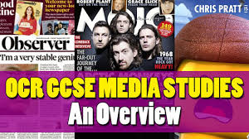

**GCSE Media Studies**

, c

**Introduction**

Media Studies is a highly analytical and theoretical based course with a small practical element. It should be chosen by students who are good at and/or enjoy English Language and Literature.

**Course structure**

**Year 10** – Students will study media language and representations through print media (magazine front covers, film posters, print adverts and newspaper front covers). Students will also study media industries and audiences through film, gaming, radio and newspapers.

**Year 11** – Students will complete their controlled assessment before studying moving media: television and music (industry, audience, language and representations).

**Equipment and Hands-on Experience**

The Media Studies department is well equipped to aid students when completing the production task, with iPads and ICT. After school on a Thursday, catch-up sessions allow students to work on their planning and production assignments and develop professional and high- quality pieces of controlled assessment.

**Future Pathways**

Studying the Media could be the first step to a career in journalism, the music industry, radio, film or television production. It could also lead you into the fields of advertising, marketing, promotions or publicity. Media Studies can be taken at A/AS and Degree level and uses skills essential in subjects such as English and the Humanities. It combines equally well with practical subjects like Graphics and ICT**.**

