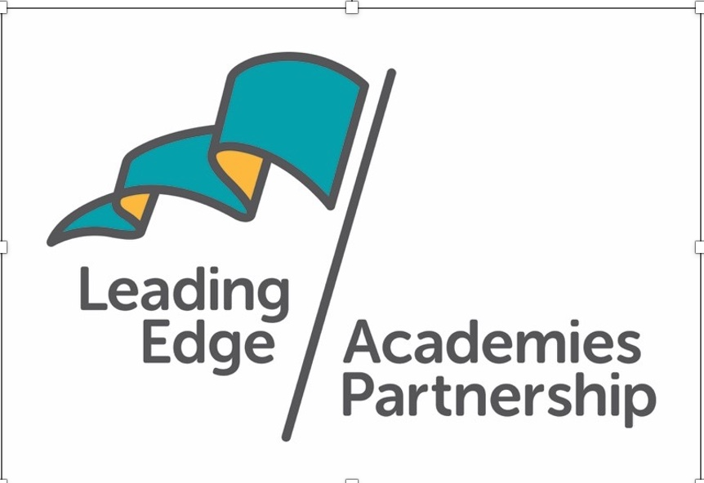

PSHE Policy

This Policy was approved in……July 2023…..

The Policy will be reviewed in……September 2025….

The names of the designated individuals are Louise Ghillyer and Ben Eddy

**Table of contents**

**Introduction ………………………………………………………………………….** 2

Context and rationale

**Values …………………………………………………………………………………**4

**External speakers …………………………………………………………………..**6

**Assessment and reporting**…………………………………………………………7

**Equality and Diversity**……………………………………………………………….8

**Confidentiality**………………………………………………………………………...8

**Links to other policies**……………………………………………………………….8

**Appendix 1**

Jigsaw curriculum.

**Appendix 2**

Jigsaw information for parents.

**Context and Rationale:**

This Policy covers our school’s approach to Personal, Social, and Health & Economic Education.

The Policy was produced by the School PSHE (Personal, Social, Health and Economic Education) Co-ordinator: Louise Ghillyer; Headteacher: Ben Eddy; and Designated Governor. Guidance provided by the PSHE Association has been used to update the Policy.

The PSHE Policy can be viewed by parents and carers on the School website.

PSHE helps to give students the knowledge, skills and understanding they need to lead confident, healthy and independent lives. It aims to help them in developing personally and socially and it tackles many of the moral, social and cultural issues that affect young people today. It equips student with a sound understanding of risk and with the knowledge and skills necessary to make safe and informed decisions.

We use PSHE to build, where appropriate, on the statutory content already outlined in the National Curriculum, the basic school curriculum and in statutory guidance on drug education, financial education, relationship and sex education (RSE) and the importance of physical activity and diet for a healthy lifestyle. RSE is an important part of PSHE education and is statutory in maintained schools.

PSHE is taught as a spiral programme which is the recurrence of themes throughout the key stages. With each delivery of the theme, the level of demand increases and learning is progressively deepened.

PSHE curriculum consists of 1 lesson per week and Drop Down Days. There are visits from external agencies and speakers such as the Police, Brook and other organisations and charities. Students’ personal, social and emotional development is also encouraged by our supportive school ethos, where all are valued and positive relationships are seen as important. A safe and secure school environment is created which s conductive to learning. Since becoming a statutory part of the curriculum in September 2020 we have developed the PSHE curriculum and now use Jigsaw PSHE.

Fowey River Academy is very much a part of the local community which we build upon within our PSHE lessons. The majority of students attending the School live in the local area and outlying villages.

In recent years’ teenage pregnancy rates in Cornwall have fallen. Teenage attitudes to relationships and sex also continue to be a concern with rising STI rates in Cornwall.

The estimate rates of smoking, healthy eating, binge drinking and obesity are similar to the England average. The death rate from smoking is better than the England average in West Cornwall. However, almost 1,000 people in Cornwall die from smoking related diseases each year.

The rate of people claiming incapacity benefits for mental illness in Cornwall is higher than the England average.

National statistics for youth unemployment highlight the importance of effective Careers Education as part of our PSHE provision.

We strive to create a PHSE curriculum which ensures the present and future wellbeing of students and has relevance in meeting their learning needs in response to local and national statistics. We acknowledge that Relationships and Sex Education is the right and responsibility of the parent. Fowey River Academy provides relationships and sex education to support parents in fulfilling this responsibility.

If parents are not happy with what the School provides in this basic curriculum, for example in PSHE lessons, with regard to relationships and sex education they have a right to withdraw their child/children from those aspects of relationships and sex education not covered by the National Curriculum Science Order.

Parents should state their wish to remove their child from such activities in writing to the Headteacher, Ben Eddy. Please note that in this School safeguarding young people is paramount.

All staff have received training re: the Prevent Duty and understand their responsibility to prevent extremism and radicalisation. Students have been advised about the issues surrounding this.

**Values:**

Our PSHE programme aims to support young people to embrace change, feel positive about who they are and enjoy healthy, safe, responsible and fulfilled lives. Our learning objectives fulfilled through the engagement of students in active learning opportunities enable students to recognise and manage risk, take increasing responsibility for themselves, their choices and behaviours and make positive contributions to their families, schools and communities.

Our PSHE programme promotes and reflects our values and respect, equality and co -operation. Students learn to recognise, develop and communicate their qualities, skills and attitudes. Students accumulate knowledge, confidence and self-esteem in order to realise their true potential. As they explore similarities and differences between people and discuss social and moral dilemmas, they learn to deal with challenges and accommodate diversity in all its forms.

The world is full of complex and sometimes conflicting values. Personal well-being helps students explore this complexity and reflect on and clarify their own values and attitudes. They identify and articulate feelings and emotions, learn to manage new or difficult situations.

Positively form and maintain effective relationships with a wide range of people. Personal wellbeing makes a major contribution to the promotion of personal development.

Education for economic well-being and financial capability aims to equip students with the knowledge, skills and attitudes to make the most of challenging opportunities in learning and work. Through their learning and experiences inside and outside school, students begin to understand the nature of the world of work, the diversity and function of business, and its contribution to national prosperity. They develop as questioning and informed consumers and learn to manage their money and finances effectively.

We know that active engagement in learning rather than passively receiving information, is most effective in teaching PSHE education. Students need opportunities to clarify their values and beliefs and rehearse and develop enquiry based, interpersonal skills.

The PSHE curriculum is based on the learning outcomes from the PSHE Personal Wellbeing and Economic Wellbeing Programmes of Study, with guidance from Cornwall Healthy Schools, as well as national guidance from PSHE Association. All students within the school receive 1 PSHE lesson a fortnight and are taught by a team of teachers, who, where possible are their form tutors, to allow for them to build positive relationships and feel comfortable in the conversations they are having. This compliments the work that is done during Tutor time.

We utilise the JIGSAW programme for the teaching of RSE and Drugs education across all year groups. A copy of the year outline and the schemes of work can be found in the appendix.

**To facilitate students learning in PSHE:**

The purpose of each lesson is made clear and linked to every day real life situations.

Appropriate learning experiences are planned and meet the needs of all the students in the class. Learning experiences draw on student’s own experiences or existing knowledge and provide a range of opportunities for students to learn, practice and demonstrate skills, attitudes and knowledge and understanding.

Time is given for students to reflect, consolidate and apply their learning.

Students are encouraged to take responsibility for their own learning and to record their own progress as well as having discussions with their form tutor and progress leader about how they can get the most from their time in school.

**Creating a safe and supportive learning environment:**

All PSHE classes develop a set of grounds rules for discussions at the start of each academic year in agreement with their teacher. The aim of the ground rules is to establish an environment of respect and collaborative so that students feel confident in discussing sensitive issues. The ground rules are reinforced in the RSE lessons at the start of RSE activity or talk from an External Speaker.

Staff routinely remind students of the protocols in place for confidentiality. If a disclosure is made, the teacher must act in accordance to the School Safeguarding Policies. The following are protocols for discussion-based lessons with students.

* No one (teacher or student ) will have to answer a personal question;
* No one will be forced to take part in discussions;
* Meanings of words will be explained in a sensible and factual way;
* Teachers may use their discretion in responding to questions and may say that the appropriate person to answer that question is the parent.

Where a member of staff is considered that a child protection issue is arising it is his/her responsibility to follow the School’s Policy in this matter.

**External Speakers and outside Agencies:**

The school leads the programme but outside visitors have a role. There is a school protocol for involving outside visitors.

We believe that external speakers can usefully supplement learning. We will ensure the external agencies and contributors’ input is part of a planned programme which consolidates and grows prior learning. All visitors follow the Safeguarding Policies in place when visiting the school, Classes and groups are always supervised by a member of the teaching staff. We work closely with the Brook Advisory Service to deliver effective RSE. All year 9 students receive a talk about the clinic and law of content. Year 10 students work with Brook covering:

* The role of Brook;
* Information about contraception, STIs, healthy and unhealthy relationships
* The consequences of unprotected sex
* The influence of alcohol and drugs leading to risk behaviours

Year 11 students also have a session with Brook. Other agencies also work with students such as the Police, School Nurse, Careers and Enterprise Company.

There are guidelines for staff on confidentiality and handling sensitive controversial issues.

**Celebration of achievement – assessment and reporting:**

As with any learning process assessment of students’ personal, social and emotional development is important. It provides information which indicates students’ progress and achievement and informs the development of the programme.

Students do not pass or fail within PSHE but have the opportunity to reflect on their own learning and personal experiences and set personal goals and agree strategies to reach them. The process of assessment has a positive impact on students’ self-awareness and self- esteem. We do not assess students in all areas of the PSHE programme, however, opportunities for students to reflect on their progress is identified. It is inappropriate to assess students’ values. In some cases it will be possible to observe and assess how students apply their knowledge, skills and understanding in simulated or real experiences. There are opportunities to record learning and progress in different ways.

Celebration of achievement contributes to build students’ self-esteem, developing a sense of community and belonging, helps create a positive atmosphere in the academy and develops student’s sense of pride. Students are rewarded using Merits and through recognition of effort and progress in PSHE at end of term awards assemblies.

**Equality and Diversity:**

We promote the needs and interests of all students, irrespective of gender, culture, ability or aptitude by reacting an inclusive, safe learning environment. Teaching will take into account the ability, age-readiness and cultural background of students in order that all students can access the PSHE curriculum. We actively promote social learning in PSHE lessons and across the school. We expect our students to show a high regard for the needs of others as encompassed in our school values. We will use PSHE education as a vehicle to address diversity and equality for all.

**Confidentiality:**

The aim of this part of the policy is to set out the School’s position on confidentiality so that it meets the requirements of:

* The Data Protection Act
* The Children’s Act
* The School Standard and Framework Act 1998
* Child Protection

Teachers are clear that they cannot be totally confidential and that if a student makes a disclosure that indicates that child abuse is taking place, the teacher is bound by law to refer that student to the designated person in the School, giving a detailed report of the disclosure.

**Monitoring**

The PSHE Lead and the Nominated Governor will have regular review meetings to ensure that the PSHE curriculum is being implemented to a high standard. The Senior Leadership Team will quality assure the PSHE provision through a subject review process.

Links to other policies:

* Behaviour Policy
* Safeguarding Policy
* SEN Policy
* RSE Policy

Appendix 1

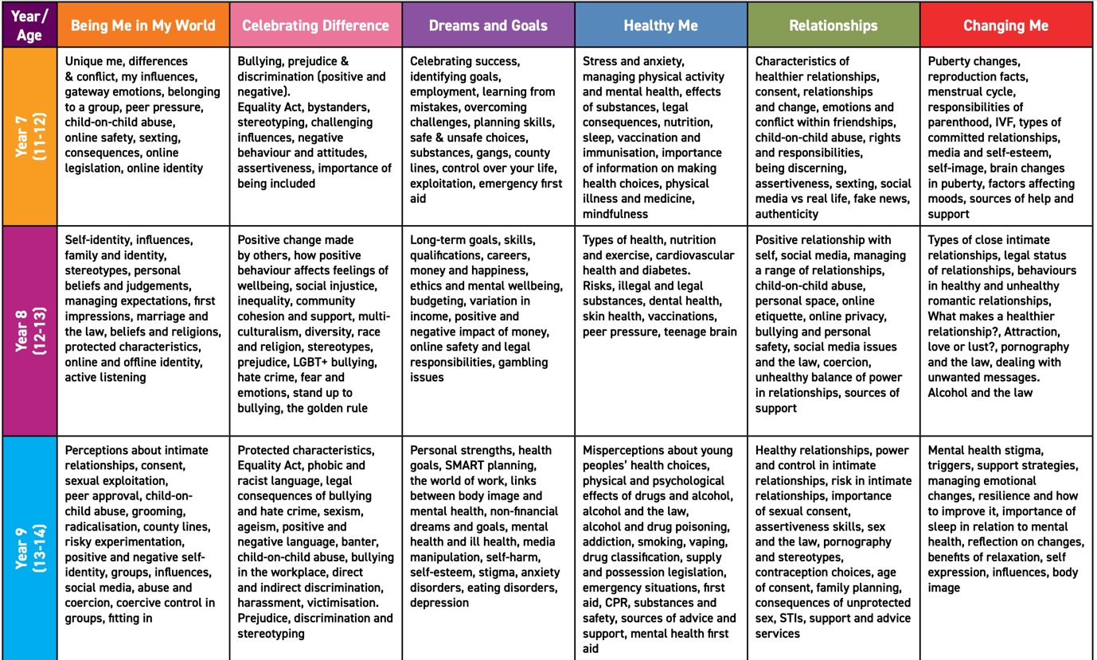

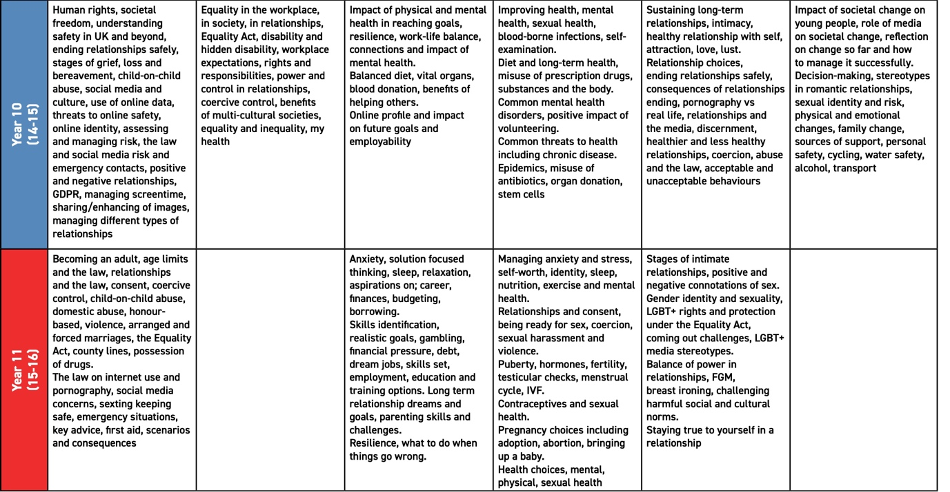

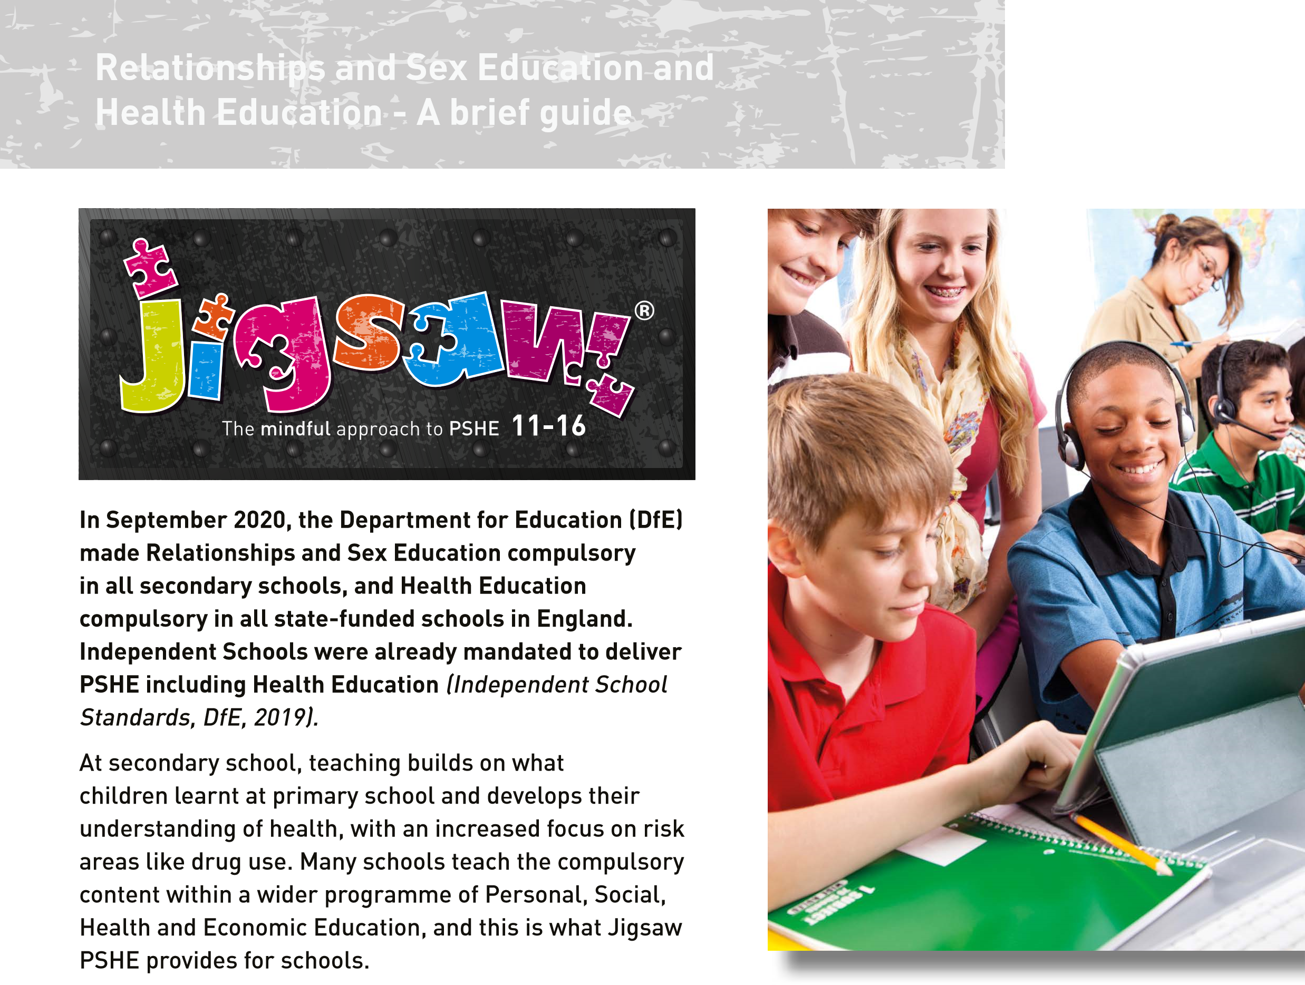**Appendix 2**

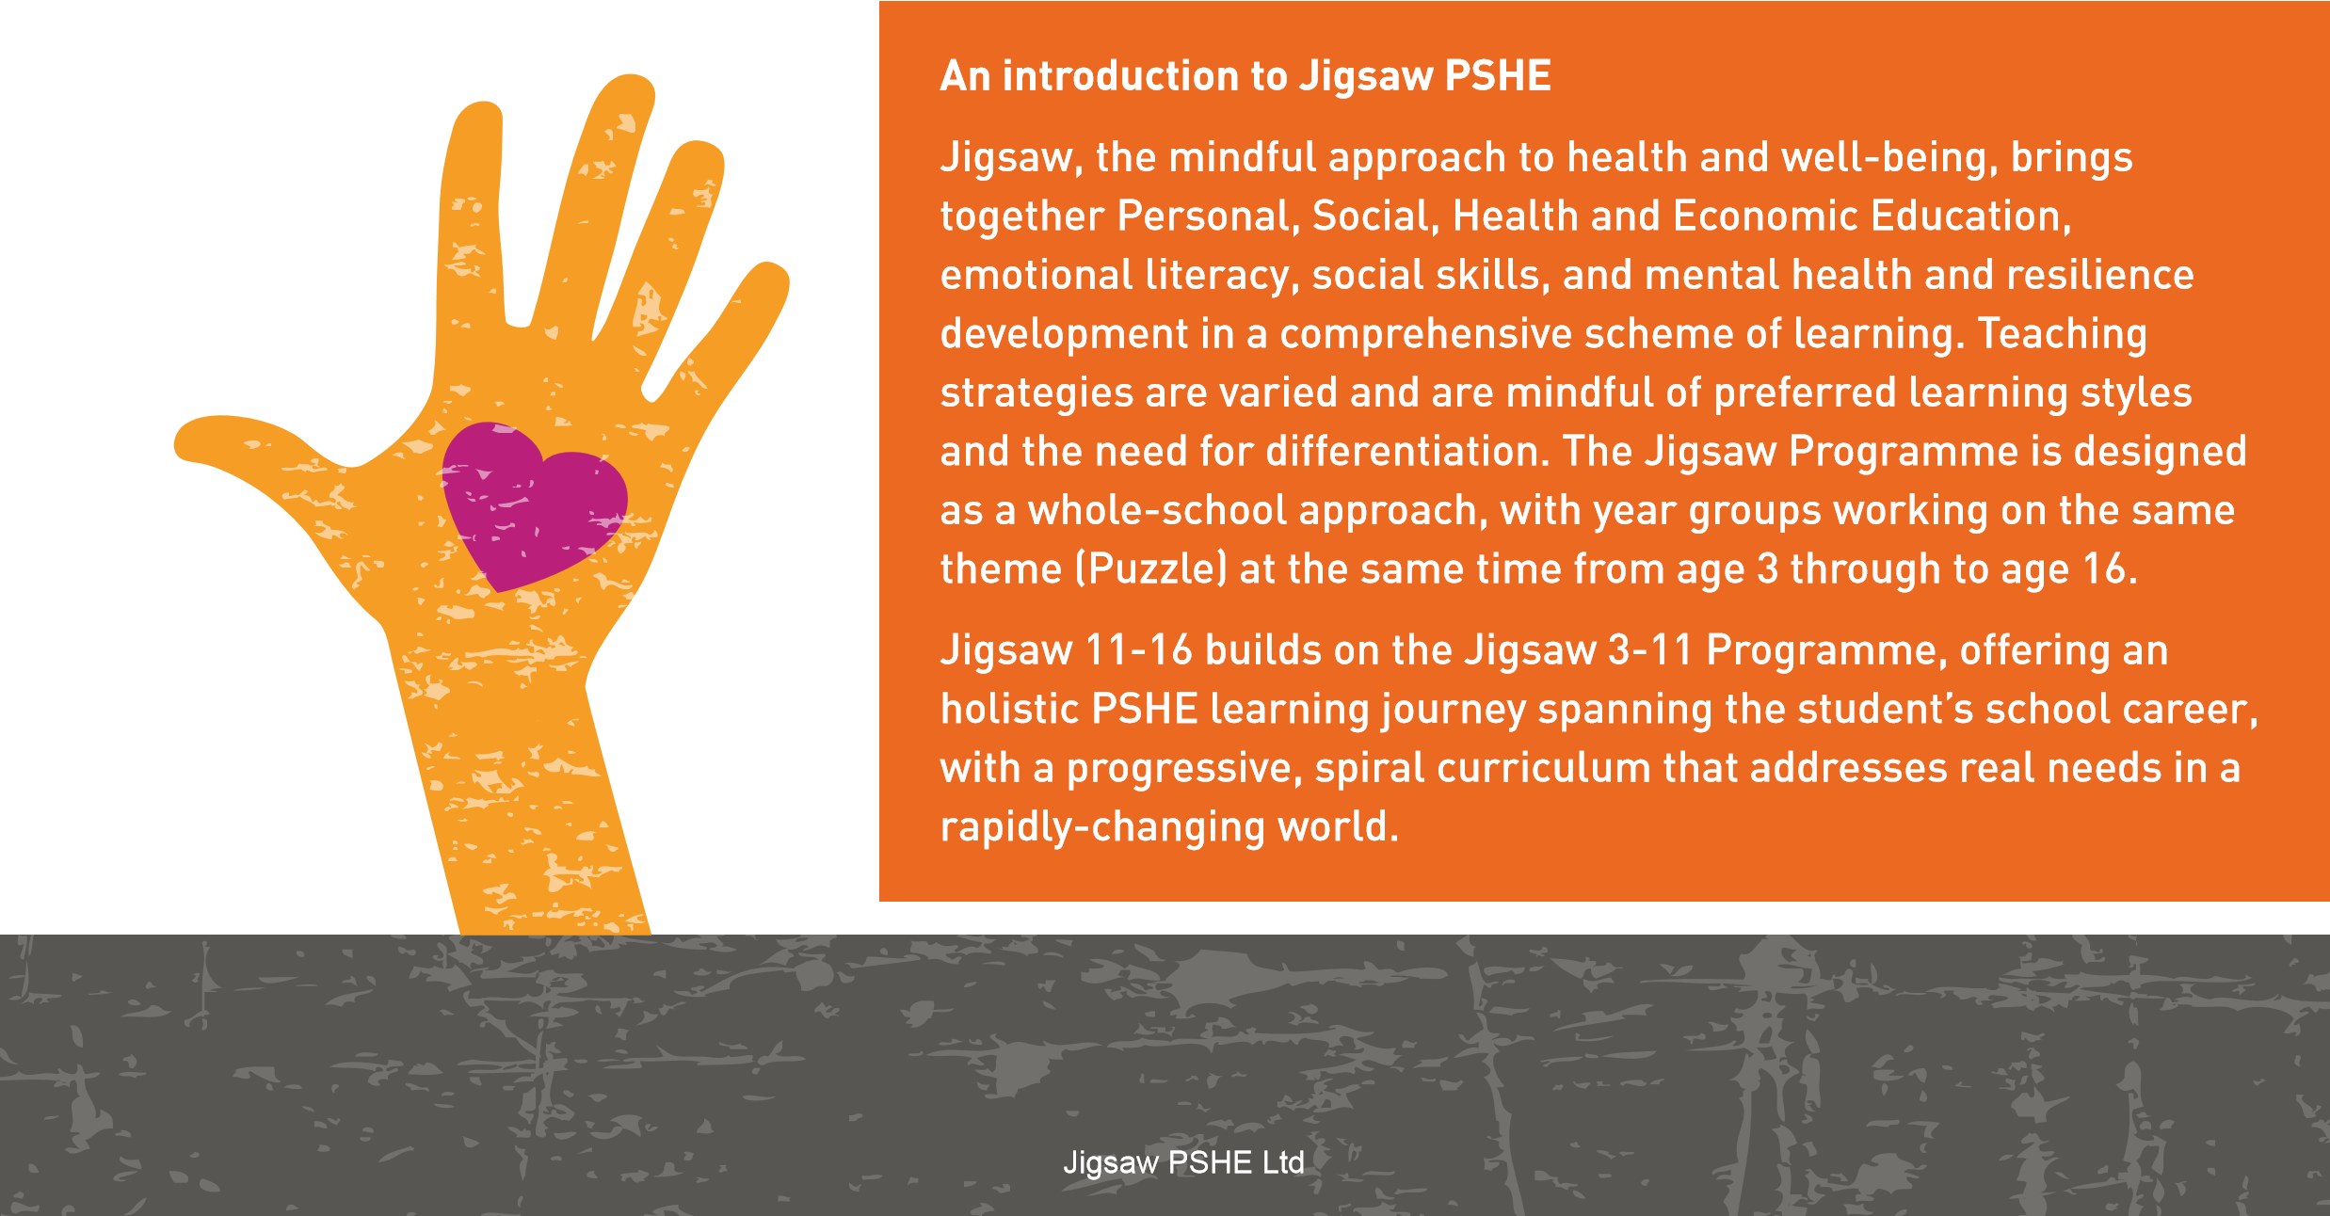

This leaflet sets out what Relationships and Sex Education and Health Education look like for students in KS3 (ages 11-14); why RSE is important; what parents and carers can do; and how Jigsaw PSHE ensures students receive the education they deserve.

The Jigsaw 11-16 programme comprises:

* A comprehensive and completely original scheme of work for 11- to 16-year-olds
* PSHE (Personal, Social, Health and Economic Education), resilience, mental health, emotional literacy, social and employability skills, British values, and SMSC (spiritual, moral, social, cultural development)
* Inclusive philosophy including Relationships and Sex Education
* 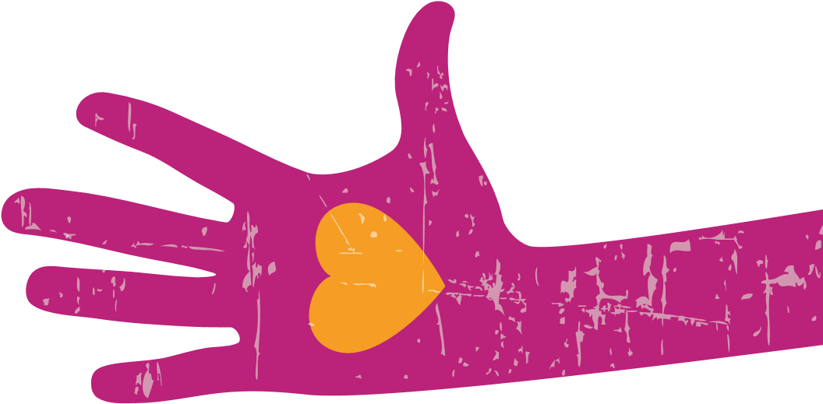The Jigsaw Approach, underpinned by mindfulness philosophy and practice And is compliant with statutory RSHE requirements (England, DfE, 2019).

Puzzles (units)

The Jigsaw 11-16 Programme includes six units of study (Puzzles), each with six lessons (Pieces), designed to be taught sequentially throughout the school year, one per term, as follows: Puzzle (Unit)

1. Being Me in My World
2. Celebrating Difference
3. Dreams and Goals
4. Healthy Me
5. Relationships
6. Changing Me

The content is student-driven and is in line with the most recent national guidance from the DfE. Jigsaw 11-16 remains a universal, core programme that will be added to and updated regularly to accommodate changing needs and contexts.

The main aim of PSHE is to empower young people to understand themselves and their minds in order to combat stress, pressure and influences that may cause them harm, and know how to lead healthy, happy, fulfilling lives.

The Jigsaw Approach is underpinned by mindfulness. Mindfulness practice enables them to observe their own thoughts and feelings, regulate them and make conscious decisions about their learning, behaviour and lives. It helps them to remain focused on the present moment and thrive in it, allaying and managing stress and anxiety.

The latest guidance recommends that schools need to teach social and emotional skills. These skills are too important to only be learnt by osmosis, which is why Jigsaw 11-16 develops them in a structured and developmental way throughout every age group. A programme like Jigsaw is so helpful to schools, because it sets out exactly how students learn best and how to teach skills that lead to better social, emotional and mental health, which, in turn, has a positive impact on learning.

Schools can be confident that a focus on well-being and mental health not only enables them to provide healthy and happy school environments for students and staff, and prepare the citizens of tomorrow with sound character and values, but also directly supports their more immediate mission, which is shared by Jigsaw: the promotion of effective learning.

What does Relationships and Sex Education (RSE) in KS3 look like for students and schools?

The aim of RSE is to give young people the information they need to help them develop healthy, nurturing relationships of all kinds, not just intimate relationships. It should enable them to know what a healthy relationship looks like and what makes a good friend, a good colleague and a successful marriage or other type of committed relationship.

It also needs to cover contraception, developing intimate relationships and resisting pressure to have sex (and not applying pressure). It should teach what is acceptable and unacceptable behaviour in relationships. This will help students understand the positive effects that good relationships have on their mental well-being, identify when relationships are not right and understand how such situations can be managed.

Parents and carers should be assured that effective RSE does not encourage early sexual experimentation. It should teach young people to understand human sexuality and to respect themselves and others. It enables young people to mature, build their confidence and self-esteem and understand the reasons for delaying sexual activity. 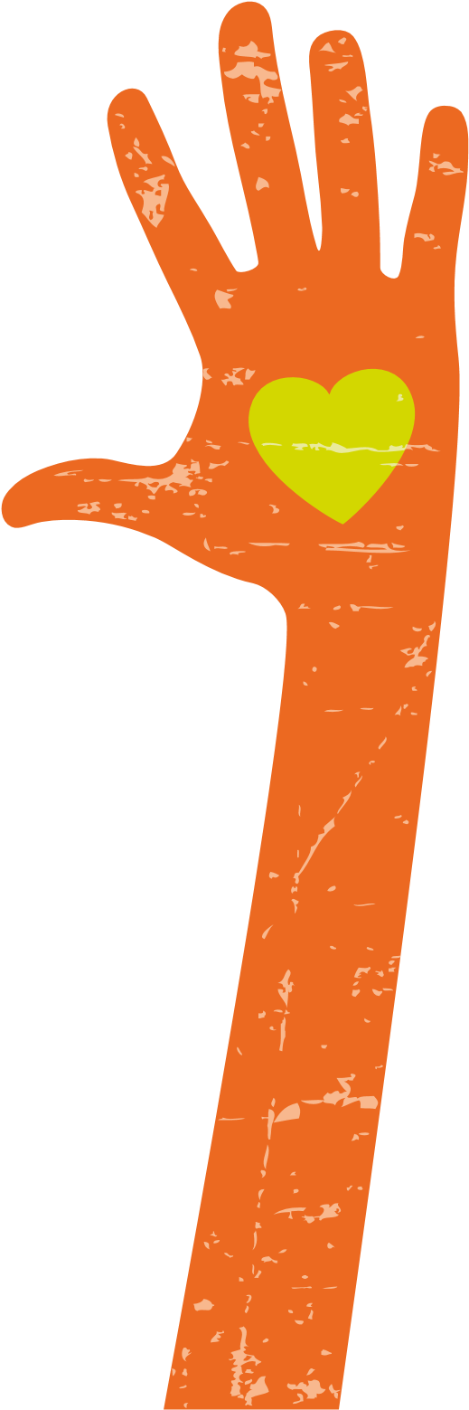 Effective RSE also supports people, throughout life, to develop safe, fulfilling and healthy sexual relationships, at the appropriate time for them.

Knowledge about safer sex and sexual health remains important to ensure that young people are equipped to make safe, informed and healthy choices as they progress through adult life. This needs to be delivered in a non-judgemental, factual way and allow scope for students to ask questions in a safe and positive learning environment. Many teachers use approaches such as distancing techniques, setting ground rules with the class to help manage sensitive discussion and using question boxes to allow pupils to raise issues anonymously - approaches advocated by Jigsaw PSHE 11-16 teaching materials.

RSE in KS3 needs to demonstrate clear progression from what is taught in Relationships Education at primary school, and as students grow up, at the appropriate time teaching is extended to include lessons on intimate relationships. Alongside this, students are also taught about family relationships, friendships and other kinds of relationships that are an equally important part of becoming an adult. This will enable students to distinguish between content and experiences that exemplify healthy relationships and those that are distorted or harmful. This applies to online and offline relationships.

This is what every school with KS3 students in England is expected to adhere to.

How they teach it is up to each individual school.

In Jigsaw PSHE, students will have the opportunity to learn in RSE…

* About families, long-term relationships like marriage, parenting and their associated laws
* About respectful relationships, including friendships, about trust, stereotypes, bullying, difference, illegal behaviour in relationships and where to find help
* About relationships within the context of the media and online – and most crucially the laws that are there to protect them and others
* About safety in relationships, including what to do if they don’t feel safe in a relationship
* About intimate and sexual relationships, and their sexual health – and how the choices they make can have a long-term impact
* About the protected characteristics in the Equality Act

It is all in the context of the whole PSHE curriculum and underpinned by the value system of the school, i.e. valuing inclusion and respect for each other, and so on. The emphasis is on changes that students will experience as they grow up: what those changes look and feel like, why they happen and how to manage them positively.

The Jigsaw Sex Education Pieces (lessons) aim to give students their entitlement to information about puberty, human reproduction, sexual health and consent, as appropriate to their age and stage of development. It is treated in a matter-of-fact manner to allay embarrassment and fear and includes sources of support and advice.

Why is RSE taught in secondary schools?

There are many reasons why RSE is taught in secondary schools, including these:

* More than ever before, students are exposed to representations of sex and sexuality through the media and the social culture around them, so their education needs to present a balanced view of relationships and sex.
* Rates of sexually-transmitted infections (STIs) and teenage pregnancy in the UK are high – as is the regret felt by young people after early sexual experiences.
* Research shows that most parents say they want the support of schools in providing RSE for their children.
* Research shows consistently that effective RSE delays first sexual experience and reduces risk-taking, despite what many people still believe to the contrary.
* Surveys of children and young people have repeatedly reported that RSE tends to be too late in their education, too focused on the biological aspects, and not enough information on building relationships.
* It is part of the statutory curriculum (DfE, England, 2020).

What is the purpose of RSE?

At Jigsaw PSHE, we believe there are four main aims for teaching RSE within the context of PSHE (Personal, Social, Health and Economic) Education and they are crucial for students to learn about.

High-quality RSE is taught…

* To enable young people to understand and respect their bodies, and be able to cope with the changes that puberty brings, without fear or confusion.
* To help young people develop positive and healthy relationships appropriate to their age, development, and so on (in other words, respect for self and others).
* To support young people to have positive self-image and body image, and to understand the influences and pressures around them.
* To help young people to make informed choices if and when they are consider starting a sexual relationship, so that they keep themselves safe and don’t have an unplanned pregnancy or sexually transmitted infection.

Won’t telling students about sex make them do it sooner and more?

No. The evidence suggests that high quality RSE does the opposite: it actually delays young people’s first sexual experience, and it helps them become much more confident and comfortable about making informed choices. We believe effective RSE takes away ignorance, not innocence.

Teaching about safety and relationships as part of PSHE Education contributes to how schools approach the safeguarding of pupils. It helps them to recognise when they and others are at risk and equips them with the skills, strategies and language they need to take appropriate action. This is crucial to fulfilling statutory duties in relation to safeguarding pupils as well as to meeting Ofsted expectations. Ofsted expressed concern in its report on PSHE that the lack of high-quality, age-appropriate RSE in over a third of schools left young people vulnerable to inappropriate sexual behaviours and exploitation. It is clear, therefore, that PSHE Education plays a vital part in helping to meet school’s responsibilities to safeguard their pupils.

Parents’ right to take students out of PSHE lessons on RSE

Parents/carers have the right to request that their child be withdrawn from some or all of sex education delivered as part of statutory RSE (but cannot withdraw their child from Relationships or Health Education). School leaders should discuss this with parents: good practice is likely to include the head teacher discussing with parents the benefits of receiving this important education and any detrimental effects that withdrawal might have on the child.

Once those discussions have taken place, except in exceptional circumstances, the school should respect the parents’ request to withdraw the child, up to and until three terms before the child turns 16. After that point, if the child wishes to receive sex education rather than be withdrawn, the school should make arrangements to provide the child with sex education during one of those terms.

Parents/carers are not permitted to withdraw their child from the Sex Education included in the National Curriculum Science, as this is a statutory subject.

If a pupil is removed from sex education, it is the school’s responsibility to ensure that the pupil receives appropriate, purposeful education during the period of withdrawal. Please note that there is no right to withdraw from Relationships Education or Health Education for any student.

If you are considering taking your child out of RSE lessons within PSHE Education, please consider the following:

* All the other students in your child’s class will have been taught this information and may well talk to your child about it and potentially mislead them or confuse them as a result. It may prove far better to allow experienced and sensitive teaching staff to teach your child in a progressive, developmental way that is grounded in research.
* They will be learning about sex and reproduction in Science lessons. The RSE in PSHE Education will echo this and will concentrate on teaching young people how to enjoy healthy relationships, improve self-esteem and self-confidence, and make healthy, informed choices. When viewed this way, it is hoped that RSE won’t be seen as contentious.
* Talk to your child’s teacher, the head teacher, or the teacher in charge of PSHE Education. Often, when parents and carers find out what is in the PSHE Education curriculum, their fears are allayed as they can appreciate it is in the best interests of their child’s lifelong learning.

What about health education in KS3?

Students are taught about physical health and mental well-being to give them the information that they need to make appropriate decisions about their own health and well-being. It needs to enable them to recognise what is normal and what is a problem in themselves and others and, when issues arise, know how to seek support as early as possible from appropriate sources.

A vital part of health education in KS3 is teaching on puberty and this includes menstruation (which follows on from what is taught in primary school). Health education should ensure all students are prepared for changes they and their peers will experience.

In Jigsaw PSHE, students will have the opportunity to learn in Health Education…

* About mental well-being, emotions, concerns and when/where to seek help
* About the internet, how to stay safe and what harms exist, including gambling, bullying and advertising
* About physical health and fitness, how to stay well and manage stress, as well as other potential health concerns
* About healthy eating, and what constitutes a balanced and appropriate diet
* About drugs, tobacco and alcohol, the law, the physical risks and dependency
* About protecting health and preventing illness, and the importance of sleep in this • About basic first aid
* About how bodies change over time, particularly in adolescence

Where can parents/carers get more information?

Parents and carers can speak to their child’s head teacher, read the school’s RSHE (PSHE) Policy, and find out more information about Jigsaw PSHE through www.jigsawpshe.com. The DfE guidance on Relationships and Sex Education and Health Education is available from

[www.gov.uk/government/publications/relationships-education-relationships-and-sex-education -rse-and-health-education](https://www.gov.uk/government/publications/relationships-education-relationships-and-sex-education-rse-and-health-education)